CRM APPLICATION FOR JEWEL MANAGEMENT SYSTEM

**COLLEGE NAME** : Sri Krishna Adithya College of Arts and Science.

**COLLEGE CODE** : bruag

**TEAM ID** : NM2025TMID22283

**TEAM MEMBERS,**

**TEAM LEADER NAME:**  VIJAYA KUMAR M

**Email:** [23bsit263vijayakumarm@skacas.ac.in](mailto:23bsit263vijayakumarm@skacas.ac.in)

**TEAM MEMBER NAME:** VIJAY C

**Email:** [23bsit262vijayc@skacas.ac.in](mailto:23bsit262vijayc@skacas.ac.in)

**TEAM MEMBER NAME:** JAYA PRAKASH E

**Email:** [23bsit227jayaprakashe@skacas.ac.in](mailto:23bsit227jayaprakashe@skacas.ac.in)

**TEAM MEMBER NAME:**  NAVEEN N

**Email:** [**23bsit147naveenn@skacas.ac.in**](mailto:23bsit147naveenn@skacas.ac.in)

**TABLE OF CONTENT :**

• INTRODUCTION CRM APPLICATION FOR JEWEL MANAGEMENT – (Developer)

**• DEVELOPMENT PHASE**

♦ Creating a Developer Account

♦ Account Activation

♦ Creation of Object

♦ Creation of TABS

♦ Creation of Lightening App

♦ Creation of Fields

♦ Creation of Profiles, Roles and Users

♦ Creation of Record Types, Page Layout.

♦ Permission set

♦ Triggers

♦ User AdoptionCreation of Reports , Dasboards and Flows

• TESTING

• RESULTS

• ADVANTAGES & DISADVANTAGES

• CONCLUSION

• APPENDIX

**INTRODUCTION :**

The jewelry business requires accurate tracking of inventory, customer relationships, billing, and sales to remain competitive in today’s market. Traditional management methods often struggle with handling large product catalogs, personalized customer demands, and real-time reporting. To address these challenges, a **Salesforce CRM-based Jewel Management System** provides a modern solution.

This application integrates jewelry business operations with Salesforce CRM features such as **customer management, sales tracking, billing automation, and analytics**. It allows jewelers to manage customer details, record purchase histories, track orders, monitor stock levels, and generate invoices efficiently. By using Salesforce, the system ensures data security, cloud-based access, and scalability, making it easier for businesses to deliver **personalized services, strengthen customer relationships, and improve decision-making**.

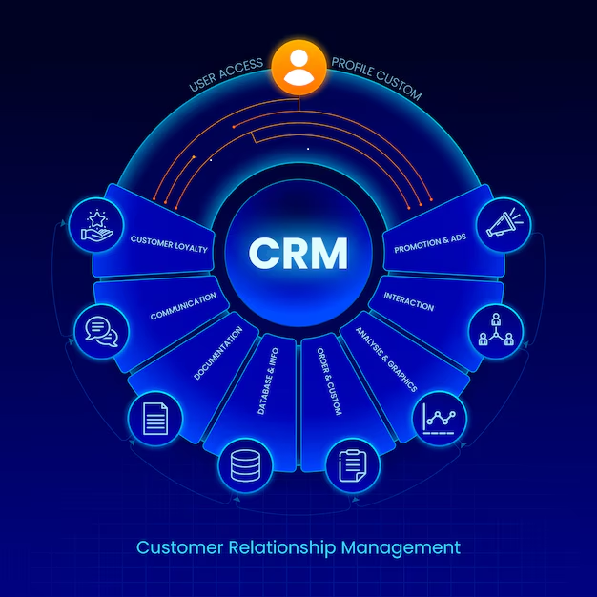

**PURPOSE :**

Creating Developer Account :

By using URL -  <https://developer.salesforce.com/signup>

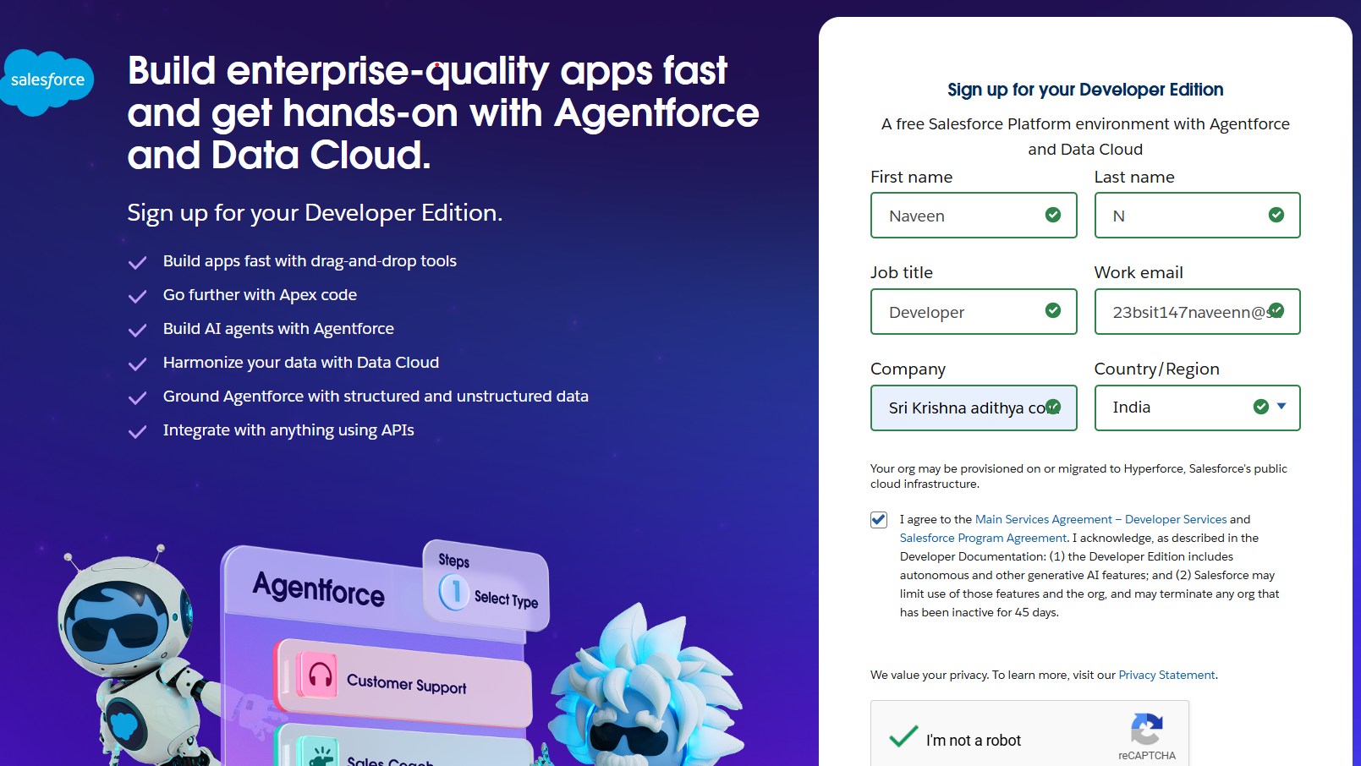

**­Flowchart:**

The flowchart for the CRM Application for Jewel Management provides a high-level overview of the system's architecture and its primary functions. It is designed to be a simple, illustrative diagram that helps stakeholders quickly understand what the application does. At its core, the JEWEL MANAGEMENT CRM acts as the central hub for all business operations. It is a single, unified platform where data is stored, processes are automated, and key activities are managed.

Each of the five surrounding boxes represents a major module of the CRM:

**1. CUSTOMER MANAGEMENT**: This branch shows that the CRM is the central point for managing all customer data, from contact information to purchase history and preferences.

**2. SALES & BILLING:** This illustrates the CRM's role in streamlining the sales process, from processing new orders to automatically generating invoices and managing payments.

**3. INVENTORY TRACKING:** This highlights how the system provides real-time visibility into the stock of jewels, helping to prevent shortages and manage valuable assets efficiently.

**4. REPAIR REQUESTS:** This demonstrates the CRM's capability to track and manage all after-sales service and repair requests, ensuring a smooth and transparent process for customers.

**5. LOYALTY PROGRAMS:** This shows the system's function in automatically managing loyalty points and membership tiers, which is crucial for retaining customers and encouraging repeat business.

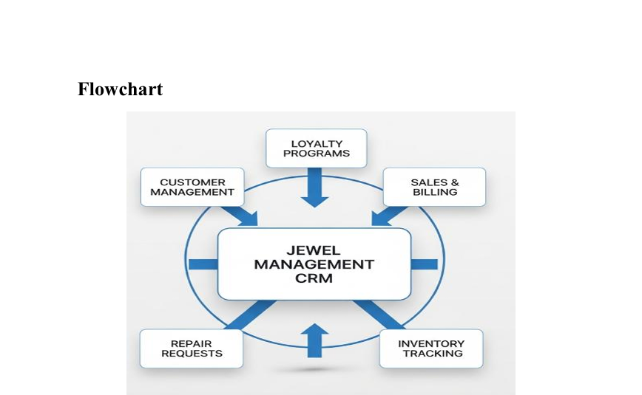

**CREATION OF OBJECT :**

Salesforce objects are database tables that permit you to store data that is specific to an organization. What are the types of Salesforce objects

Salesforce objects are of two types:

**1. Standard Objects:** Standard objects are the kind of objects that are provided by salesforce.com such as users, contracts, reports, dashboards, etc.

**2. Custom Objects:** Custom objects are those objects that are created by users. They supply information that is unique and essential to their organization. They are the heart of any application and provide a structure for sharing data.

**The Required Objects :**

o Jewel Customer Object

o Item Object

**Jewel Customer Object :**

The purpose of creating a Jewel Customer custom object is to store and manage information about Customer.

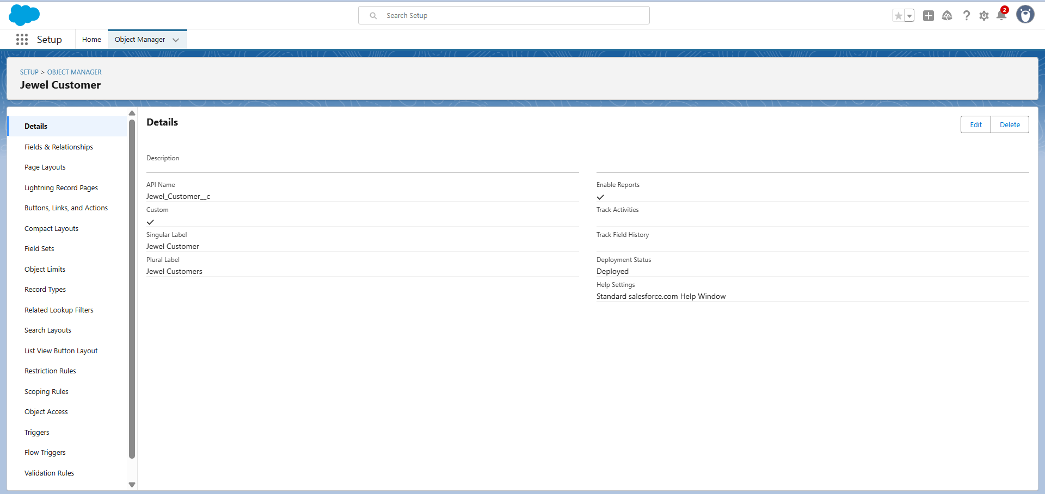

**Item Object :**

The purpose of creating a Item object is to manage the inventory of gold and silver items.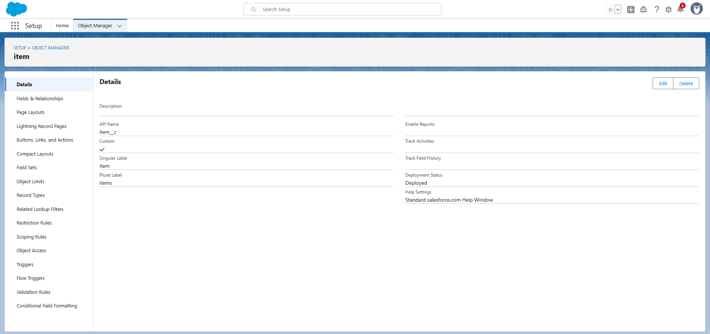

Both the Objects are Created Succesfully .

**Creation of Tabs :**

A tab is like a user interface that is used to build records for objects and to view the records in the objects.

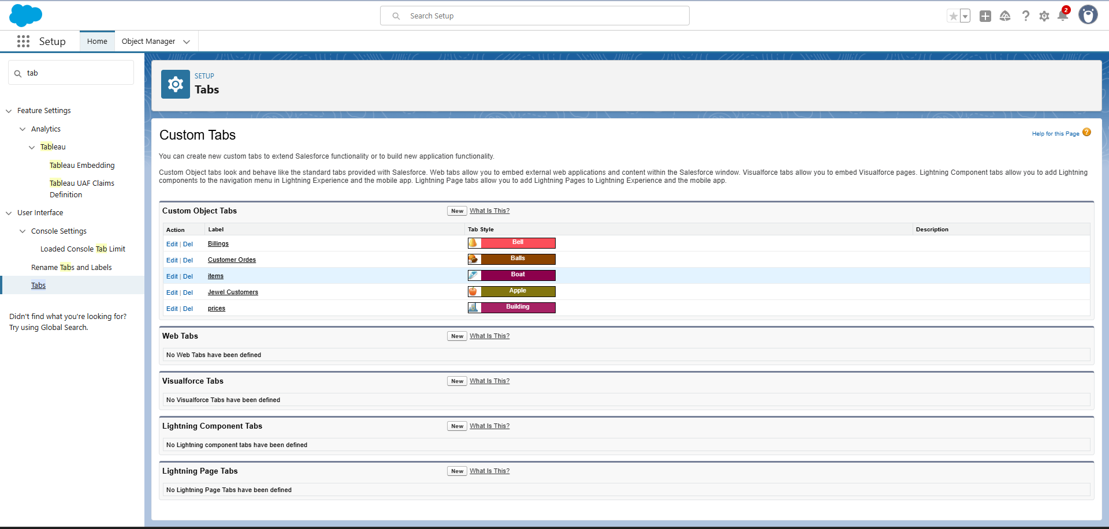

**Creation of the Lightening App :**

Lightning apps let you brand your apps with a custom color and logo. You can even include a utility bar and Lightning page tabs in your Lightning app. Members of your org can work more efficiently by easily switching between apps.

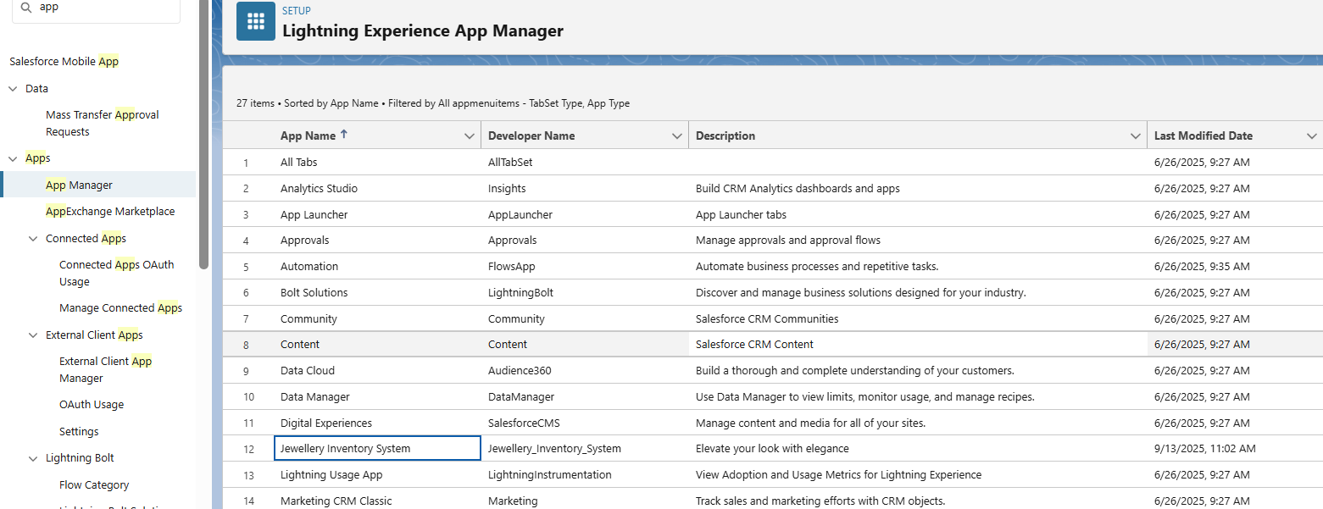

**Creation of Fields :**

When we talk about Salesforce, Fields represent the data stored in the columns of a relational database. It can hold any valuable information that you require for a specific object. Hence, the overall searching, deletion, and editing of the records become simpler and quicker.

**Custom Fields:**

On the other side of the coin, Custom Fields are highly flexible, and users can change them according to requirements. Moreover, each organiser or company can use them if necessary. It means you need not always include them in the records, unlike Standard fields. Hence, the final decision depends on the user, and he can add/remove Custom Fields of any given form.

**Jewel Customer Object Fields :**

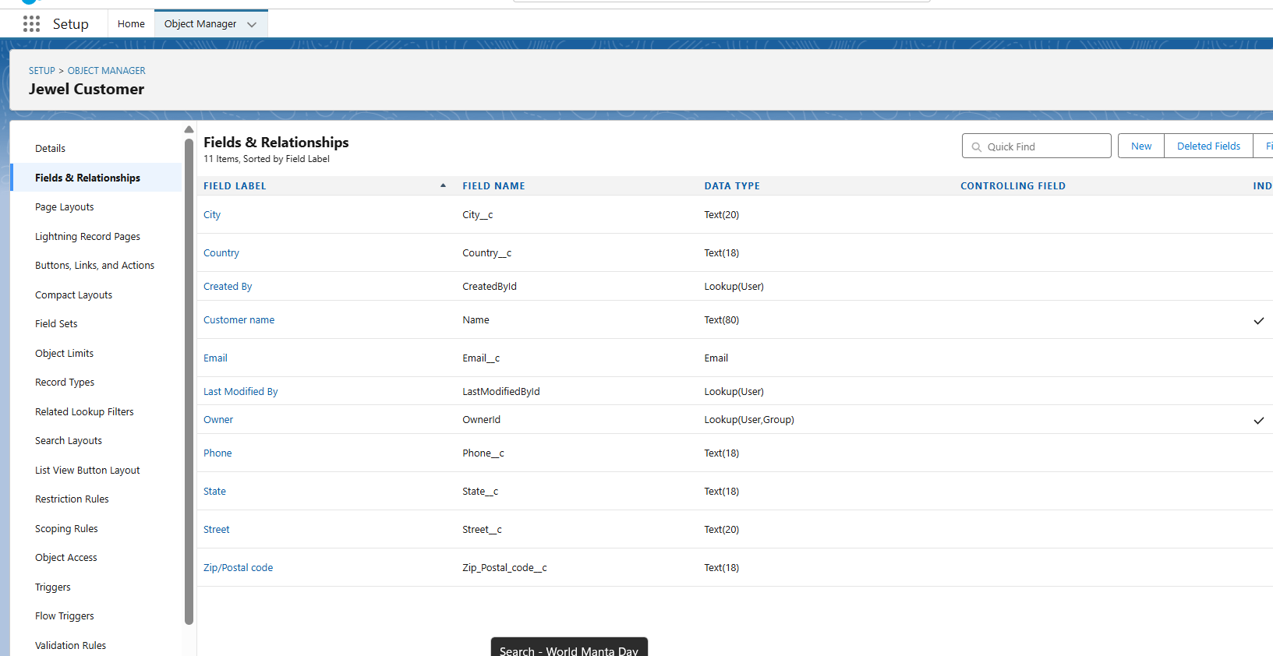

**Item Object Fields :**

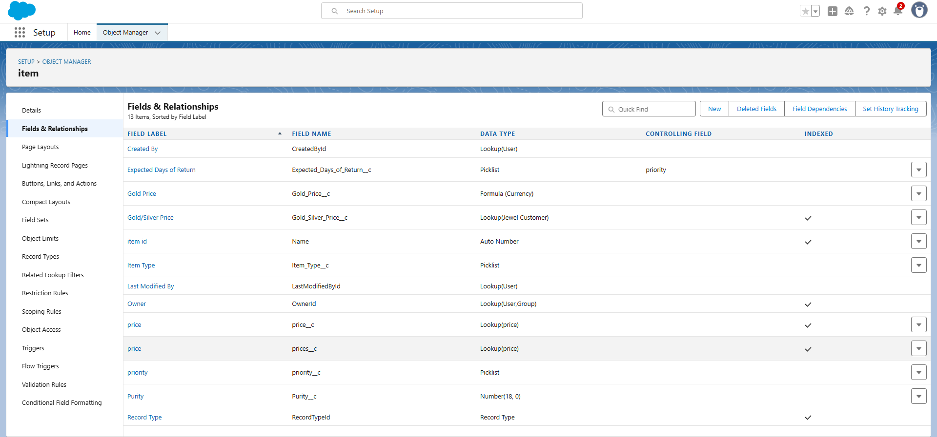

**Billing Object Fields:**

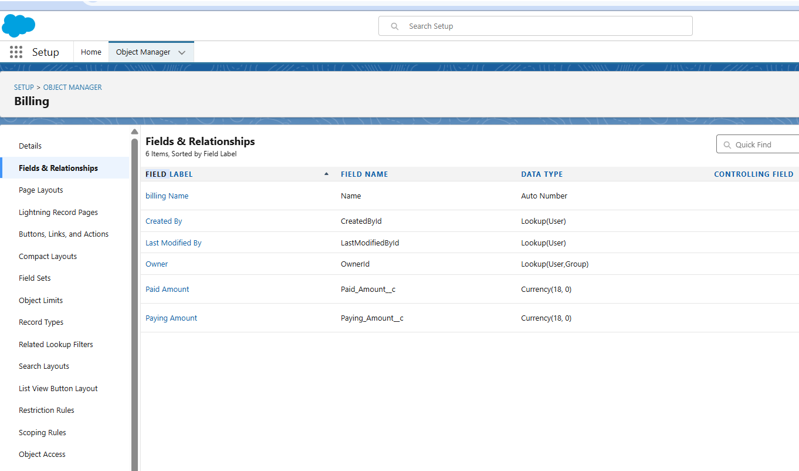

**Price Object Fields:**

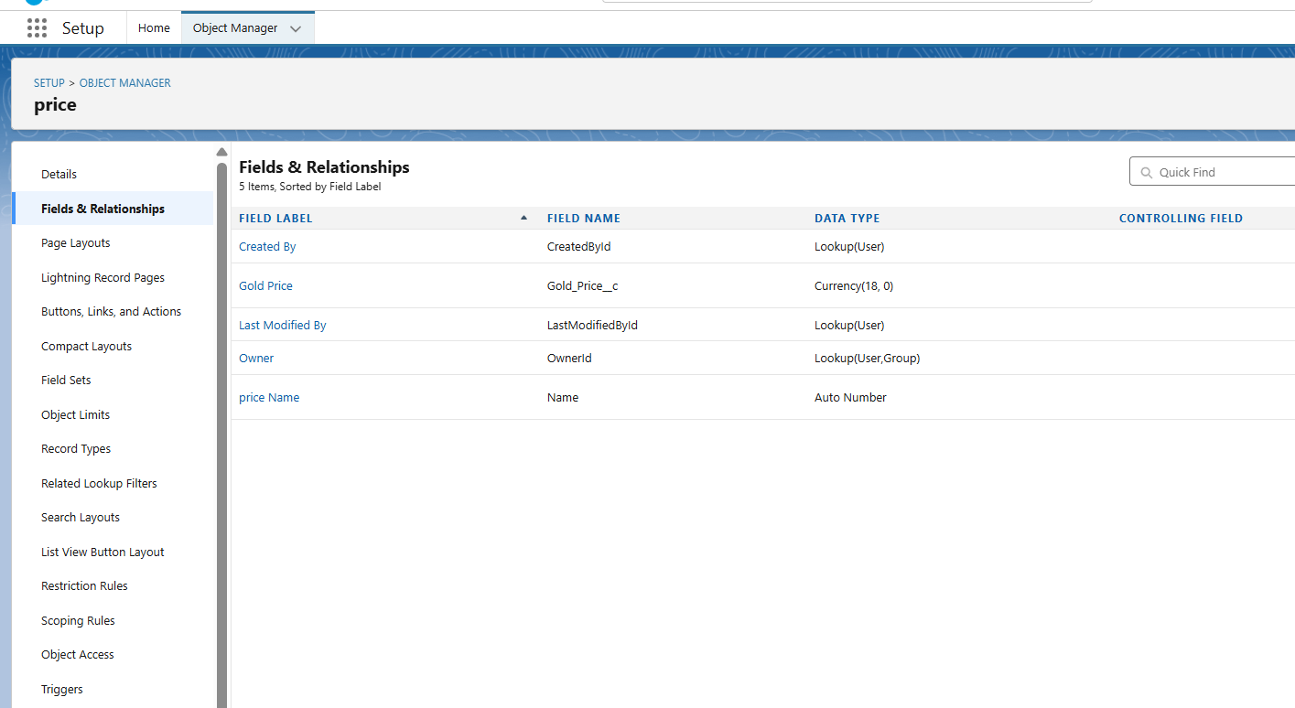

**Customer Order Fields:**

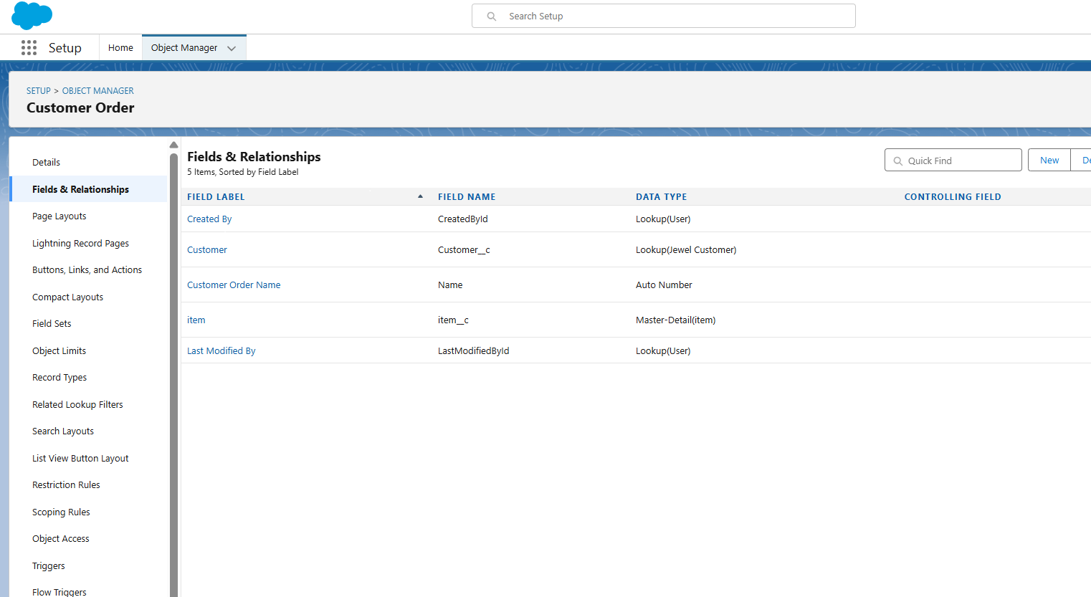

**Creation of Profiles :**

A profile is a group/collection of settings and permissions that define what a user can do in salesforce. Profile controls “Object permissions, Field permissions, User permissions, Tab settings, App settings, Apex class access, Visualforce page access, Page layouts, Record Types, Login hours & Login IP ranges. You can define profiles by the user's job function. For example System Administrator, Developer, Sales Representative.

• Gold Smith Profile

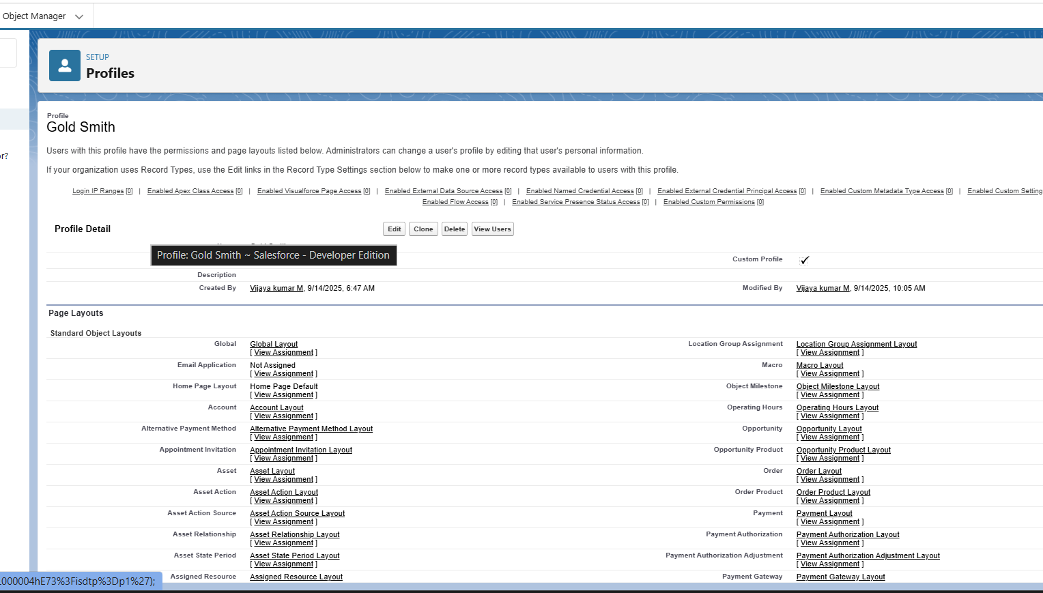

**• Worker Profile**

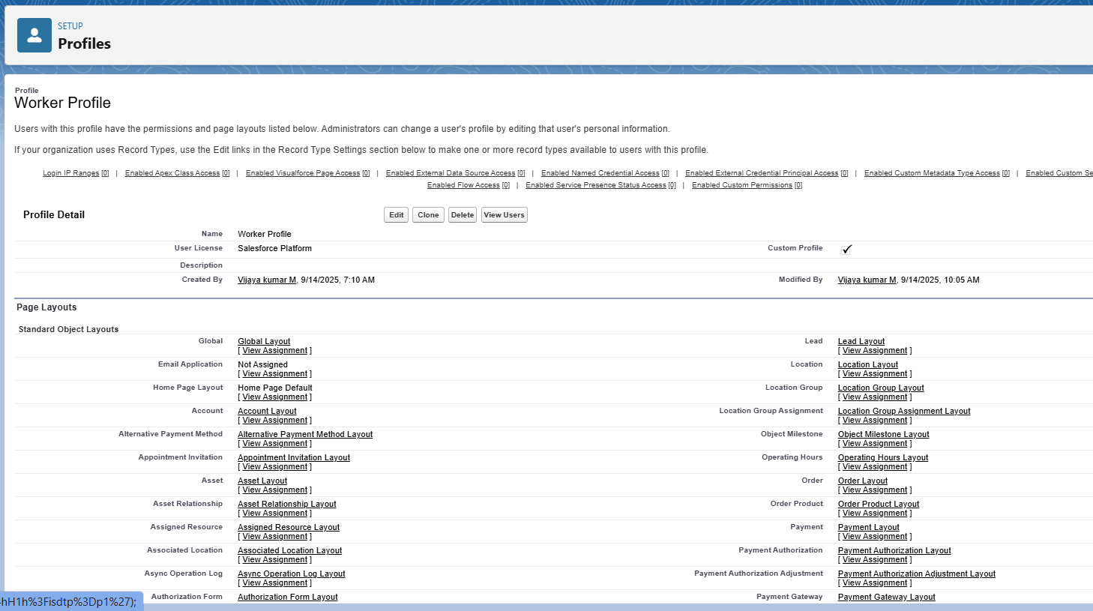

**Creation of Roles:**

A role in Salesforce defines a user's visibility access at the record level. Roles may be used to specify the types of access that people in your Salesforce organisation can have to data. Simply put, it describes what a user could see within the Salesforce organisation.

▪ Gold Smith

▪ Worker

**­­**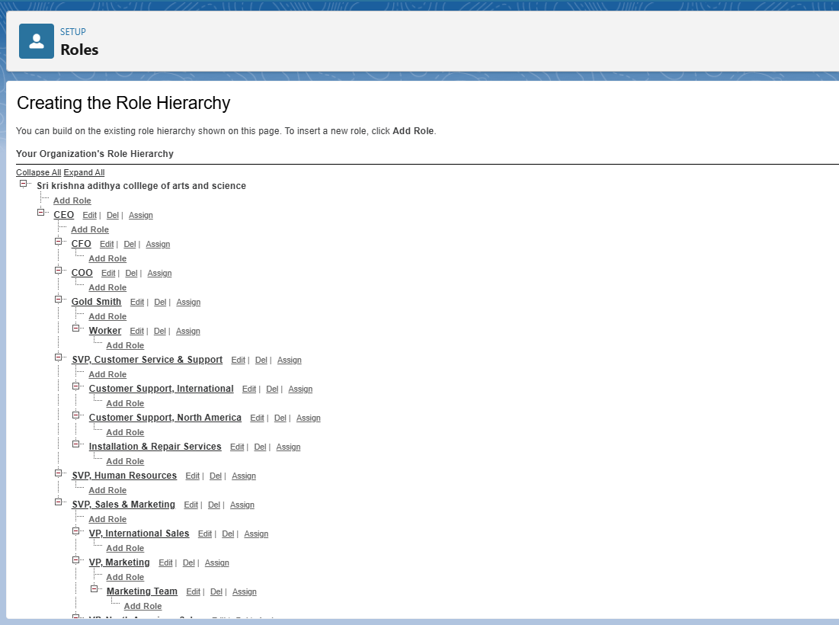

**Creation of Users :**

A user is anyone who logs in to Salesforce. Users are employees at your company, such as sales reps, managers, and IT specialists, who need access to the company's records. Every user in Salesforce has a user account. The user account identifies the user, and the user account settings determine what features and records the user can access.

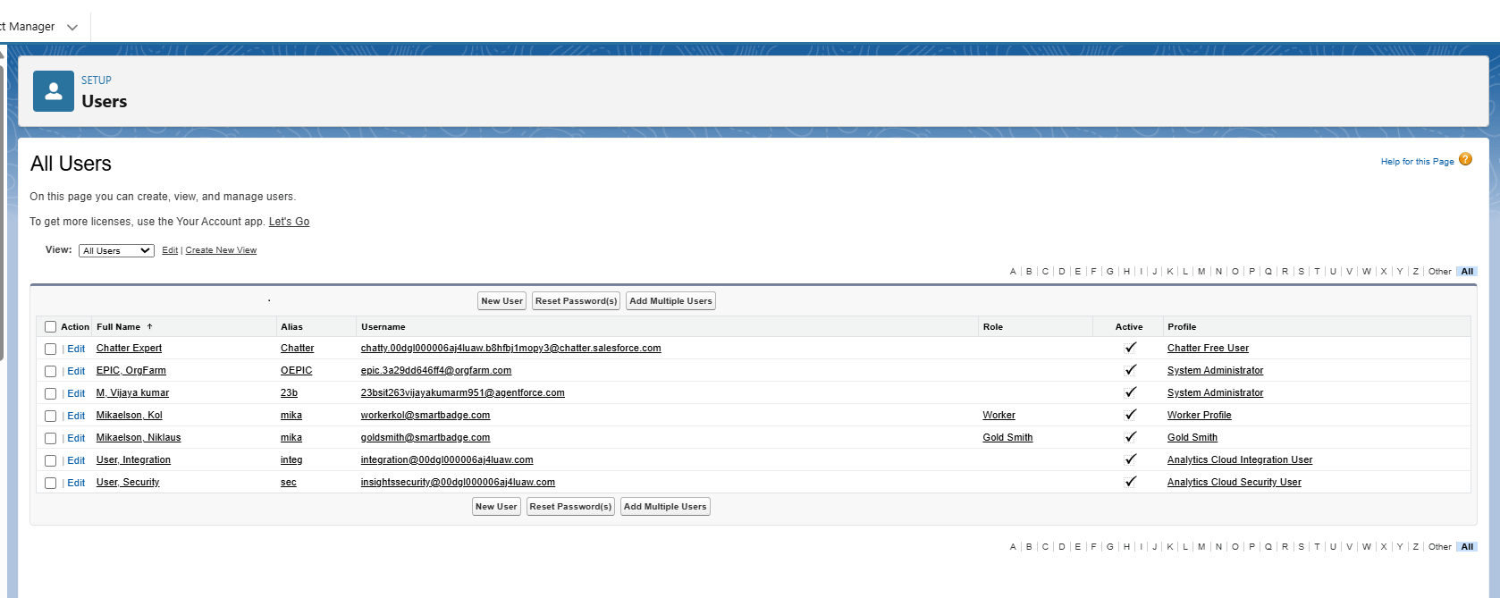

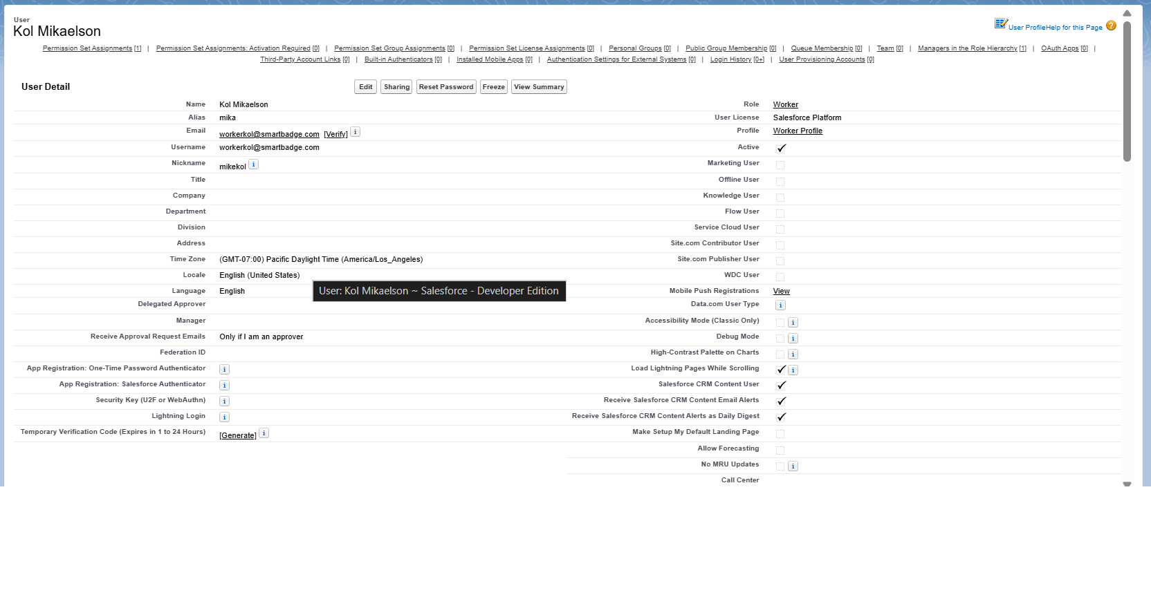

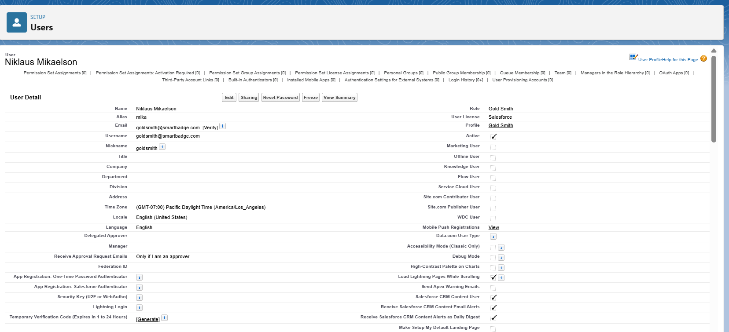

**Creation of Page Layouts :**

Page Layout in Salesforce allows us to customise the design and organise detail and edit pages of records in Salesforce. Page layouts can be used to control the appearance of fields, related lists, and custom links on standard and custom objects' detail and edit pages.

▪ Layout for Gold

▪ Layout for Silver

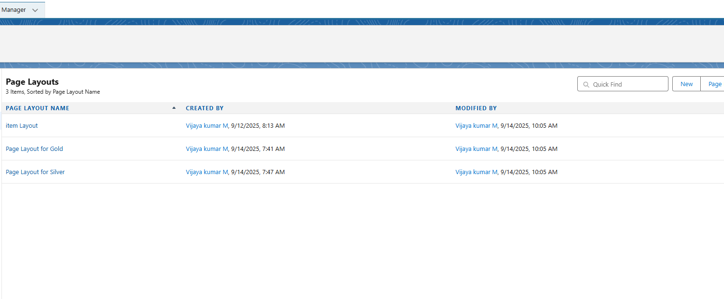

**Creation of Record Type :**

Record Types are a way of grouping many records of one type for that object. These can be applied to any standard or custom object, and allow you to have a different page layout, fields, required fields, and picklist values.

▪ Gold ▪ Silver

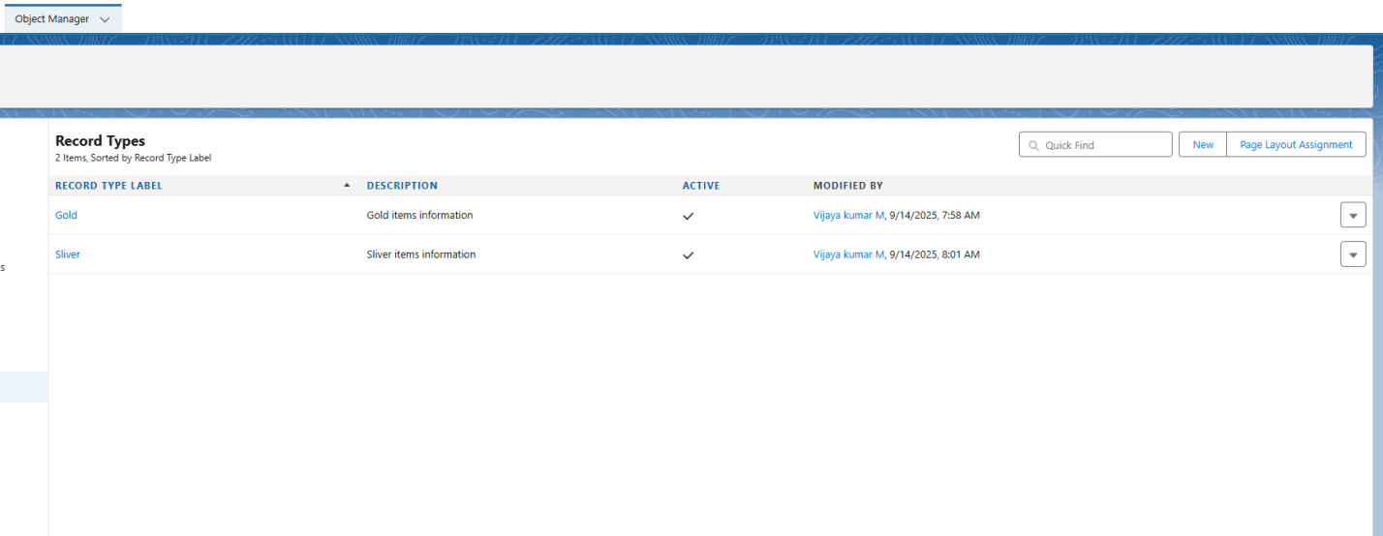

**Creation of a Permission Set :**

A standard permission set consists of a group of common permissions for a particular feature associated with a permission set licence. Using a standard permission set saves you time and facilitates administration because you don't need to create the custom permission set.

Per to Worker

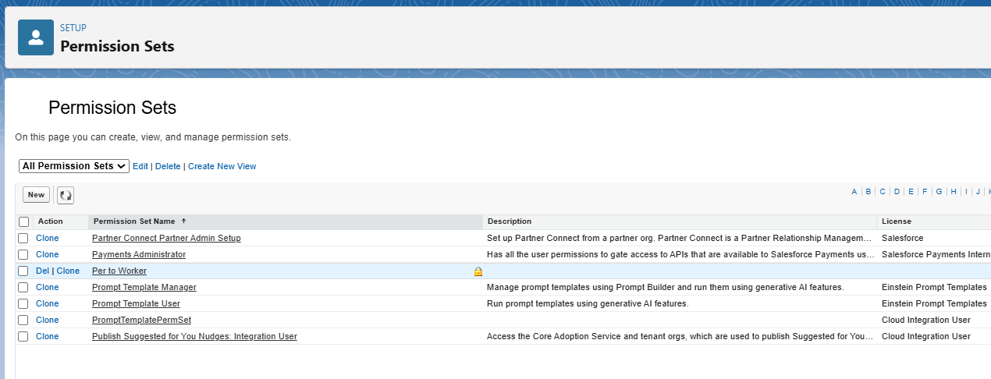

**Creation of Triggers :**

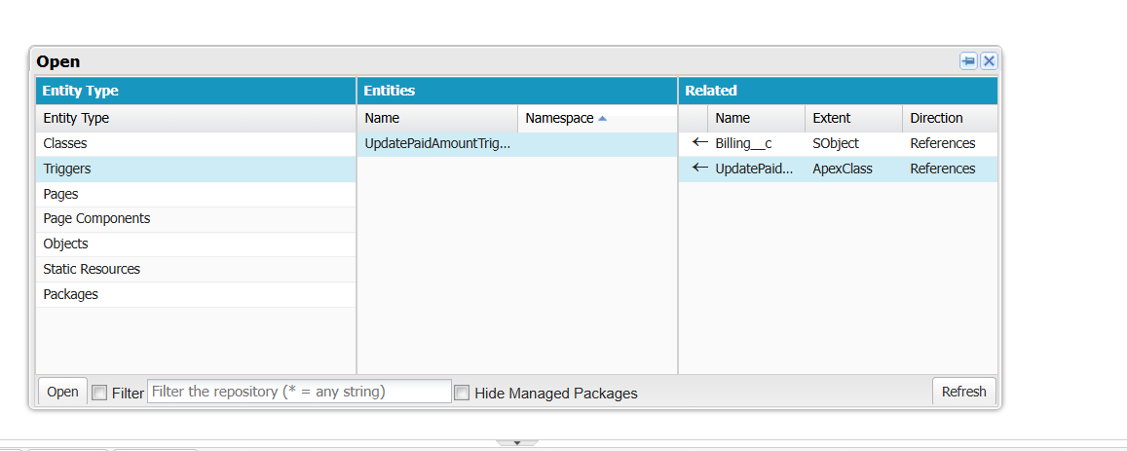

**User Adoption :**

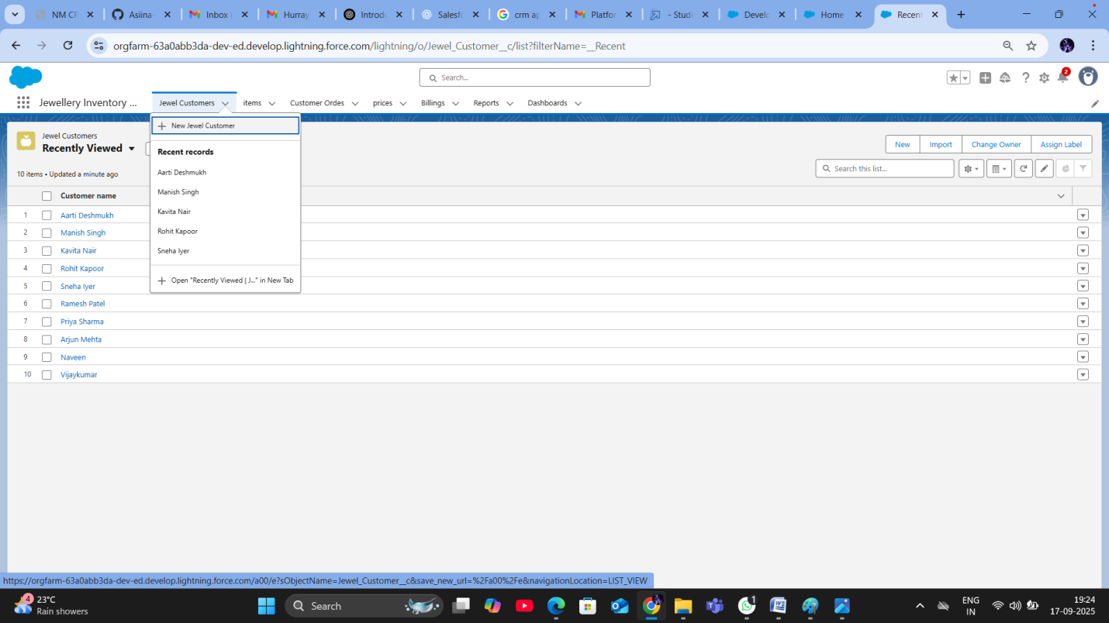

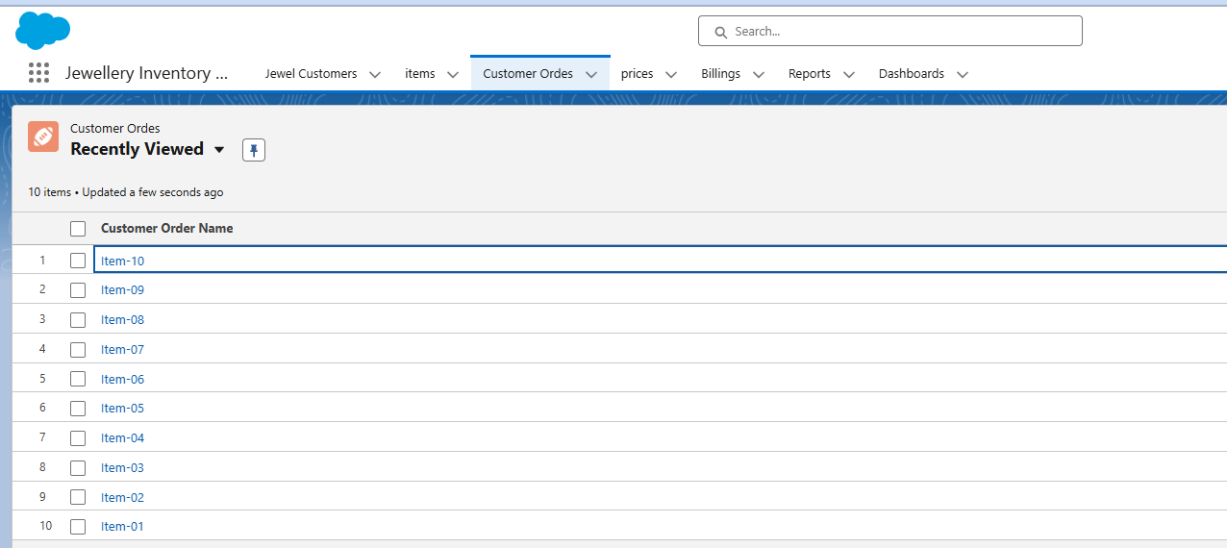

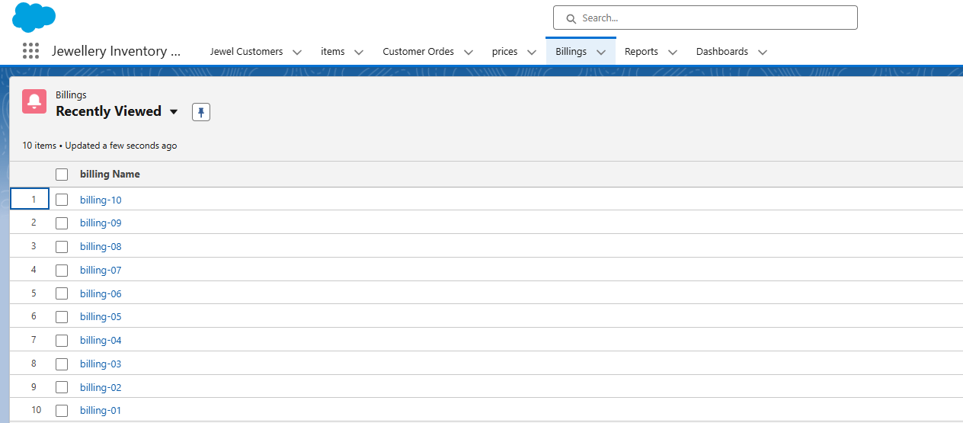

**Creation of Reports :**

Reports give you access to your Salesforce data. You can examine your Salesforce data in almost infinite combinations, display it in easy-to-understand formats, and share the resulting insights with others. Before building, reading, and sharing reports, review these reporting basics.

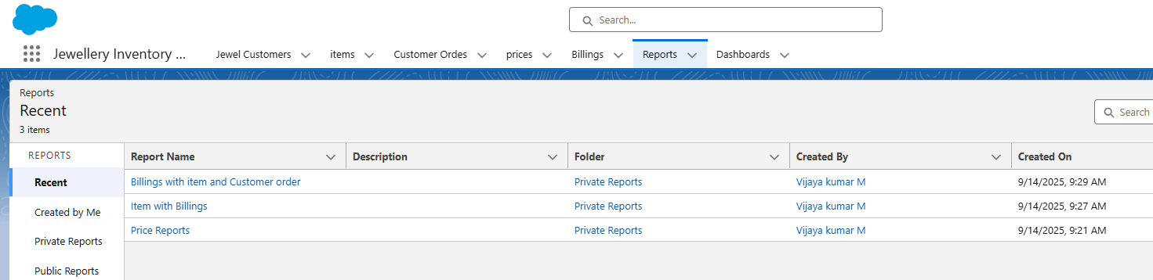

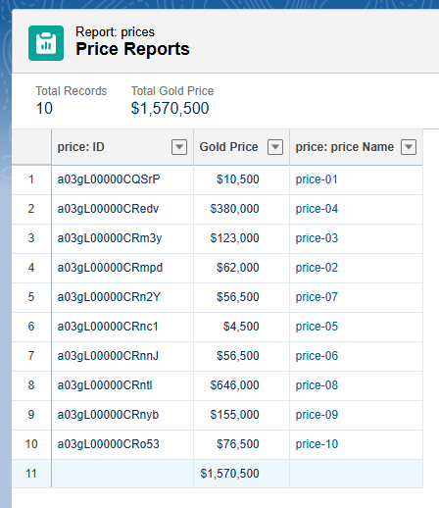

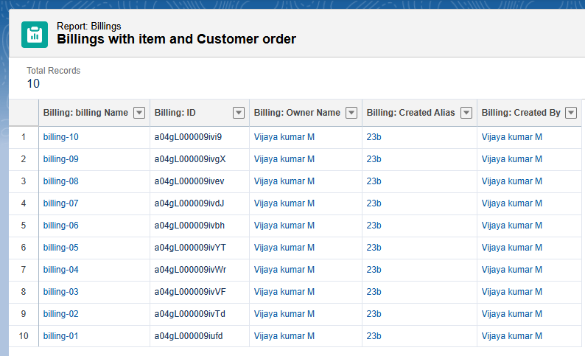

**Creation of Dashboards :**

Dashboards help you visually understand changing business conditions so you can make decisions based on the real-time data you’ve gathered with reports. Use dashboards to help users identify trends, sort out quantities, and measure the impact of their activities.

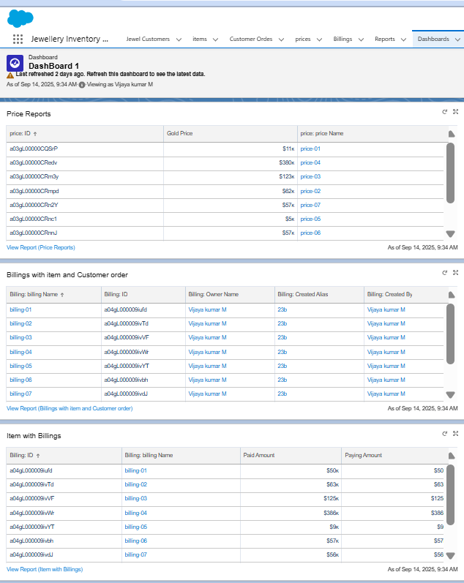

**Creation of Flow :**

In Salesforce, a flow is a powerful tool that allows you to automate business processes, collect and update data, and guide users through a series of screens or steps. Flows are built using a visual interface and can be created without any coding knowledge.

**Billing Alert Flow :**

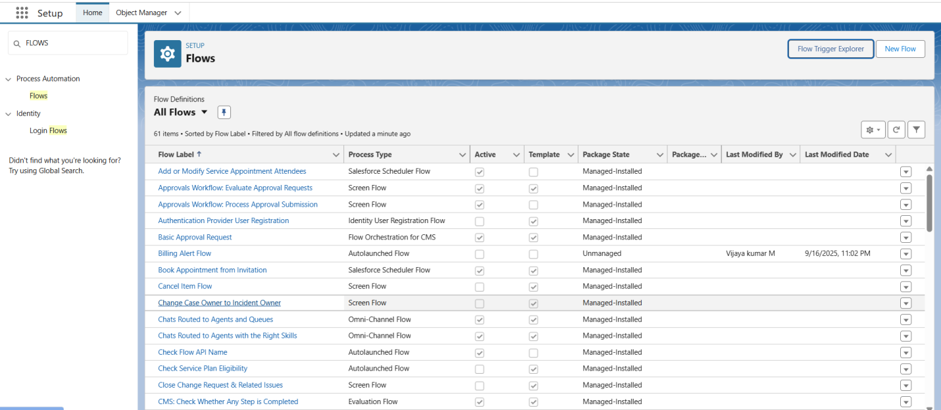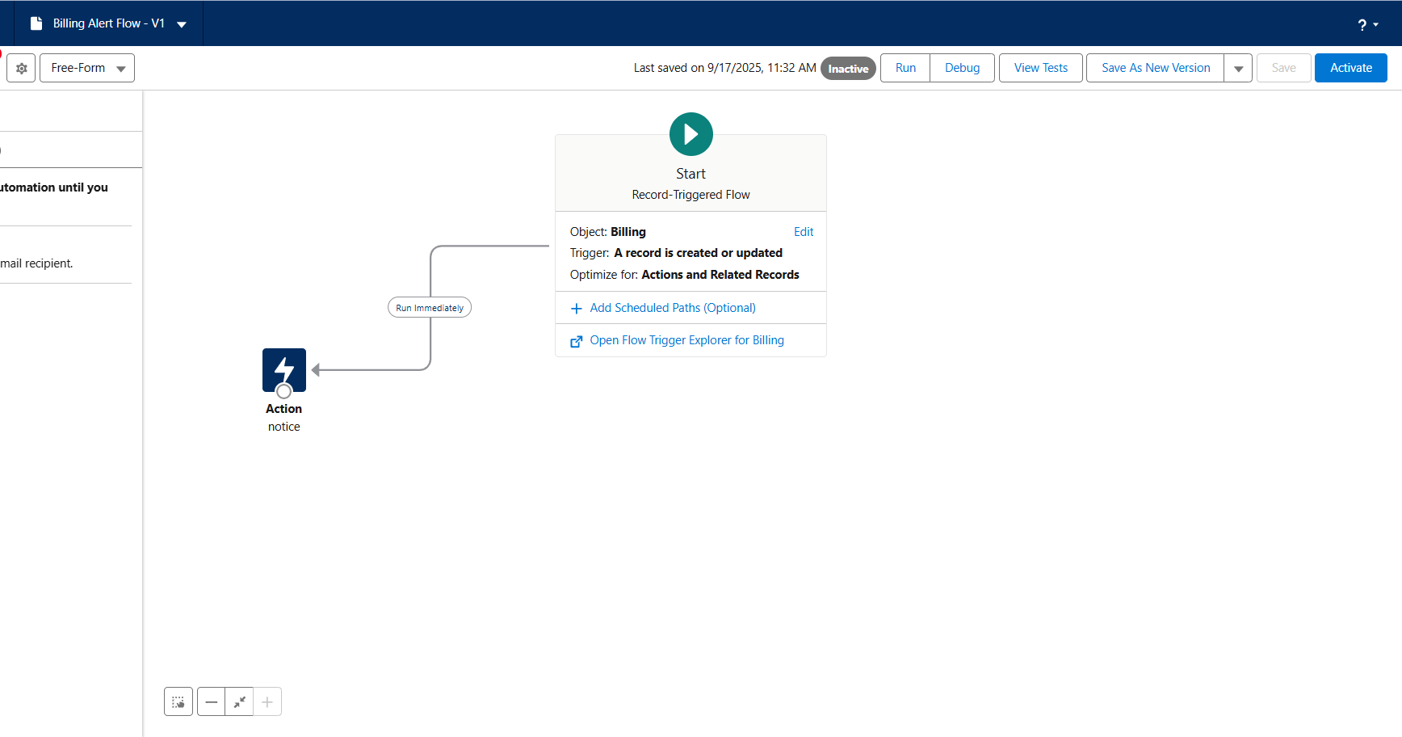

**TESTING & RESULT:**

A series of tests were conducted to validate the functionality of the system:

• **Validation Rules**: Tested by entering invalid data to ensure rules for email format, phone numbers, and stock availability worked as expected.

• **Flows:** Tested the order-to-invoice flow to confirm that invoices were generated accurately and automatically.

• **Triggers:** Tested the loyalty points trigger by completing an order and verifying that the correct number of points was credited to the customer's account.

• **Approval Processes**: Tested by creating a high-value order and confirming that it was routed to the manager for approval and that the status updated correctly.

• **Email Alerts**: Tested the email templates and alerts by confirming that notifications were sent for purchase confirmations, reminders, and approval requests



.

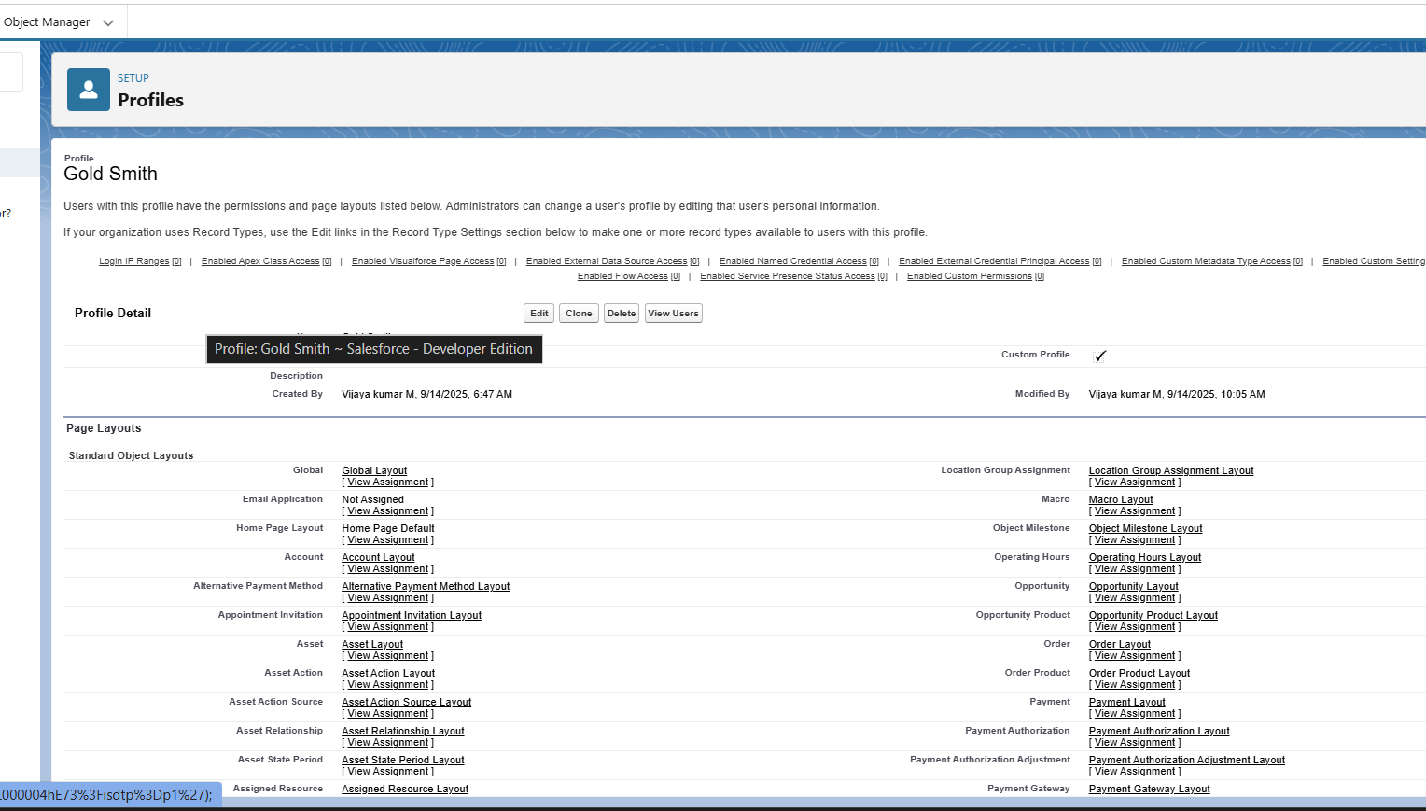

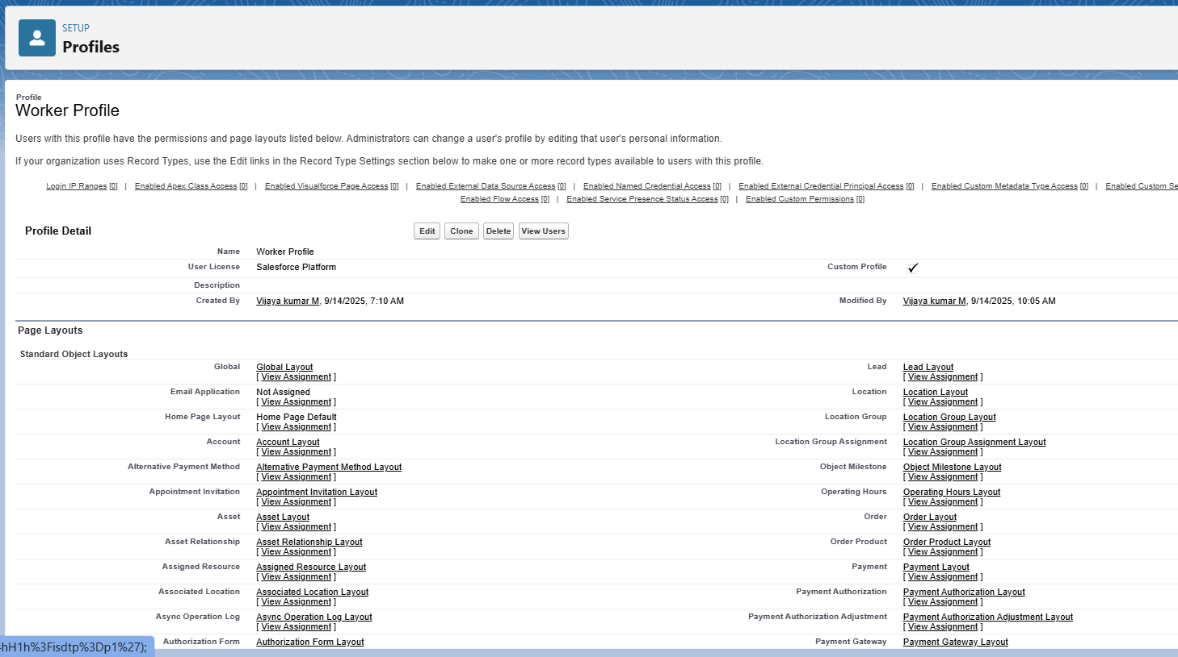



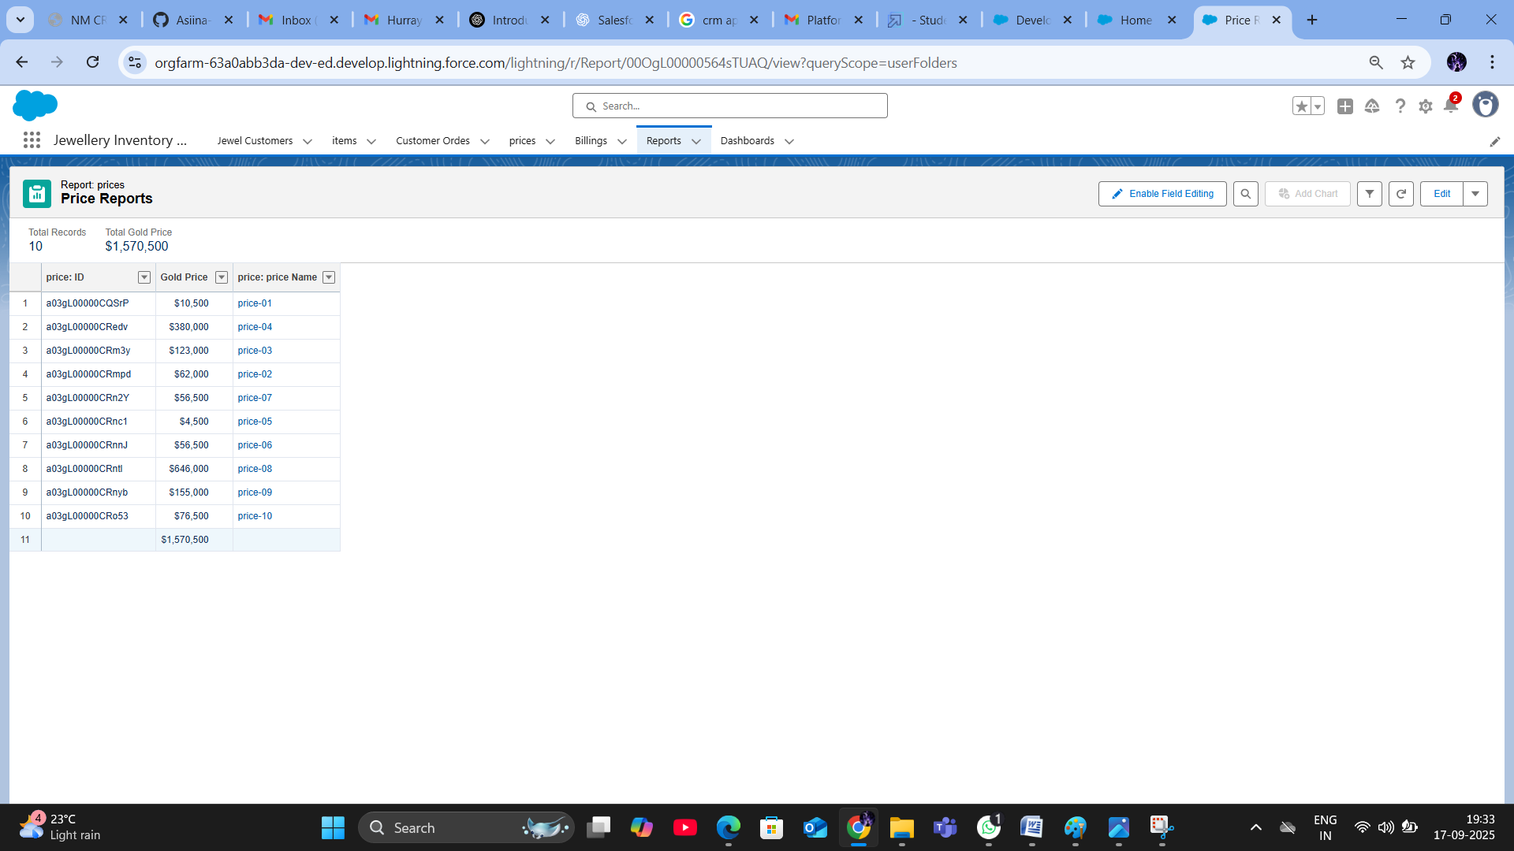

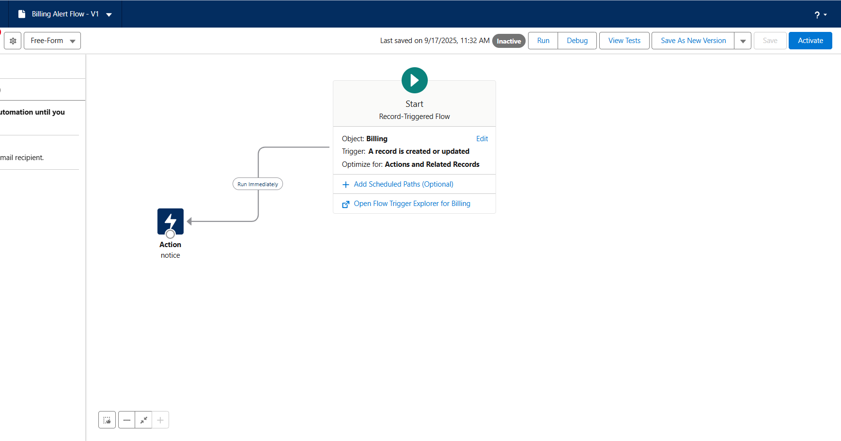

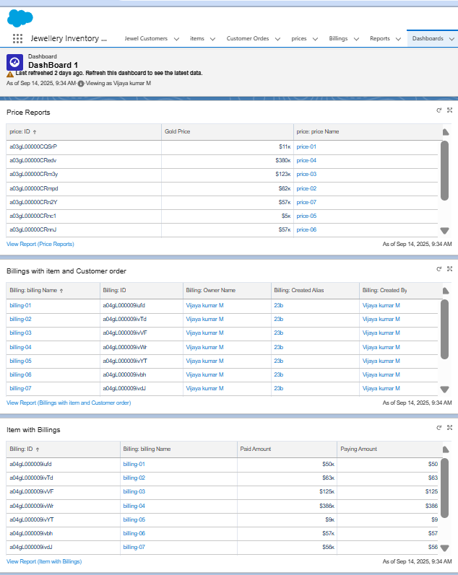

**ADVANTAGES AND DISADVANTAGES**

**ADVANTAGES :**

**1.Centralized Customer & Inventory Data**

• All customer, sales, and jewelry inventory data is stored in one place.

• Real-time visibility of customer purchase history, preferences, and trends.

**2. Personalization & Customer Engagement**

• Salesforce CRM tools allow targeted offers, loyalty programs, and personalized recommendations.

• Helps jewelers improve repeat purchases and maintain long-term customer relationships.

**3. Cloud-Based & Accessible Anywhere**

• Being in Salesforce, the system is accessible on mobile, tablet, or desktop

. • Ideal for jewelers with multiple branches or sales teams on the move.

**4. Automation of Business Processes**

• Automates tasks like billing, reminders for maintenance/cleaning services, order tracking, vendor communication, etc.

• Reduces manual errors and improves efficiency.

**5. Powerful Analytics & Reporting**

• Dashboards provide insights on best-selling products, seasonal demand, stock shortages, and customer lifetime value.

• Supports data-driven decision-making.

**Disadvantages**

**1.Internet Dependency**

* The system requires a stable internet connection to function.

**2. Initial Training**

* Users will need training to adapt from manual processes to the new Salesforce system.

**3. Customization Efforts:**

* While Salesforce is highly customizable, initial setup and specific jewel-industry configurations require a dedicated development effort.

4**. Dependency on Internet**

* As it’s cloud-based, a stable internet connection is necessary. • Downtime or poor connectivity can disrupt operations.

**5. Data Migration Challenges**

* Shifting legacy jewelry data (old invoices, customer history, stock details) into Salesforce can be complex and error-prone.

**CONSLUSION :**

The Salesforce-based CRM Jewel Management System delivers a strategic advantage to jewelers by streamlining operations, personalizing customer engagement, and enabling smarter business insights. While implementation may require investment and training, the system’s scalability and powerful tools ensure sustainable growth and improved customer satisfaction. For businesses aiming to modernize and expand, this solution offers a strong foundation for future success.

**APPENDIX :**

**Source Code** : Provided in Apex Classes and Triggers

**Class Name** : UpdatePaidAmountTriggerHandler

public class UpdatePaidAmountTriggerHandler {

    public static void handleBeforeInsert(List<Billing__c> newBillings) {

        for (Billing__c billing : newBillings) {

            billing.Paid_Amount__c = billing.Paying_Amount__c;

        }

    }

    public static void handleBeforeUpdate(Map<Id, Billing__c> oldBillingsMap,

List<Billing__c> updatedBillings) {

        for (Billing__c billing : updatedBillings) {

            Billing__c oldBilling = oldBillingsMap.get(billing.Id);

            Decimal oldPaidAmount = oldBilling.Paid_Amount__c;

            billing.Paid_Amount__c = oldPaidAmount + billing.Paying_Amount__c;

        }

    }

}

**Create the trigger**

trigger UpdatePaidAmountTrigger on Billing__c (before insert, before update) {

    if (Trigger.isInsert) {

        UpdatePaidAmountTriggerHandler.handleBeforeInsert(Trigger.new);

    } else if (Trigger.isUpdate) {

        UpdatePaidAmountTriggerHandler.handleBeforeUpdate(Trigger.oldMap,

Trigger.new);

    }

}